Lab 6:
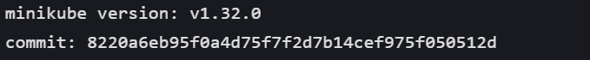
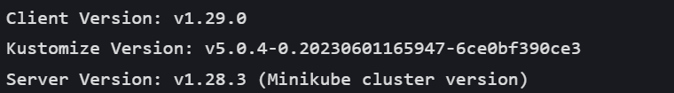

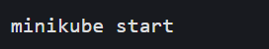
Step 1: Start Minikube Cluster

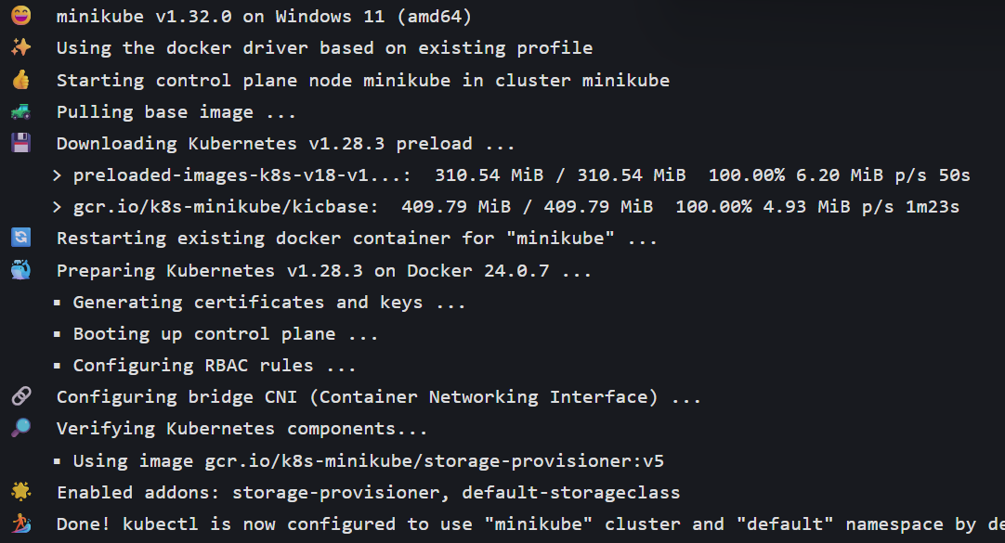

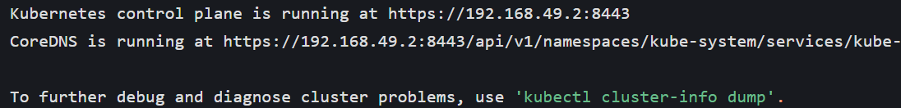

Step 2: Deploy the App
Step 3: Explore the App

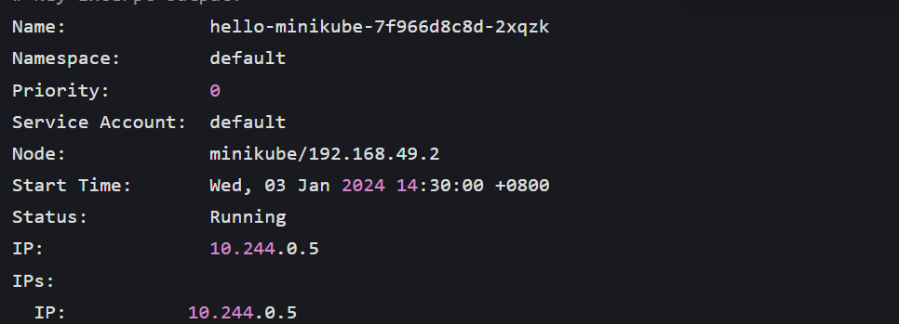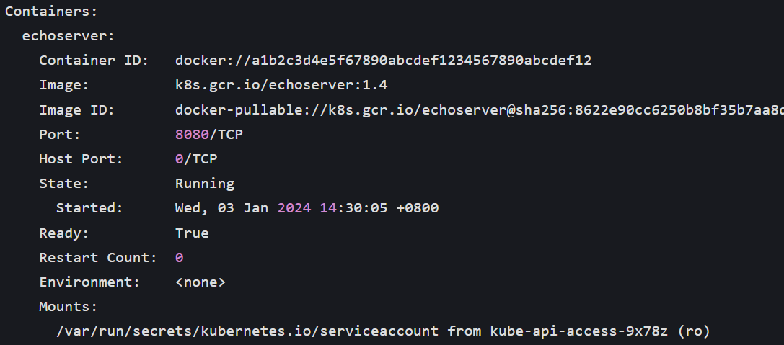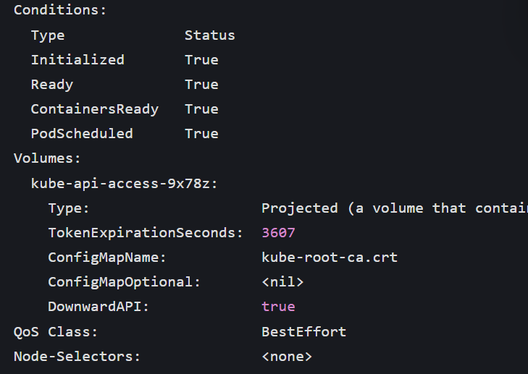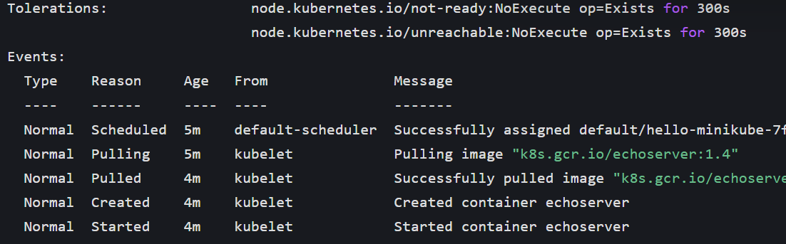

Step 4: Expose the App as a Service
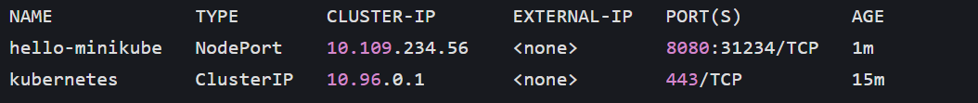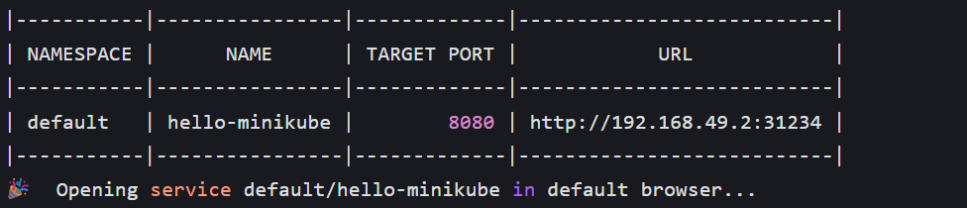
Simulated Browser Response (Echoserver App)
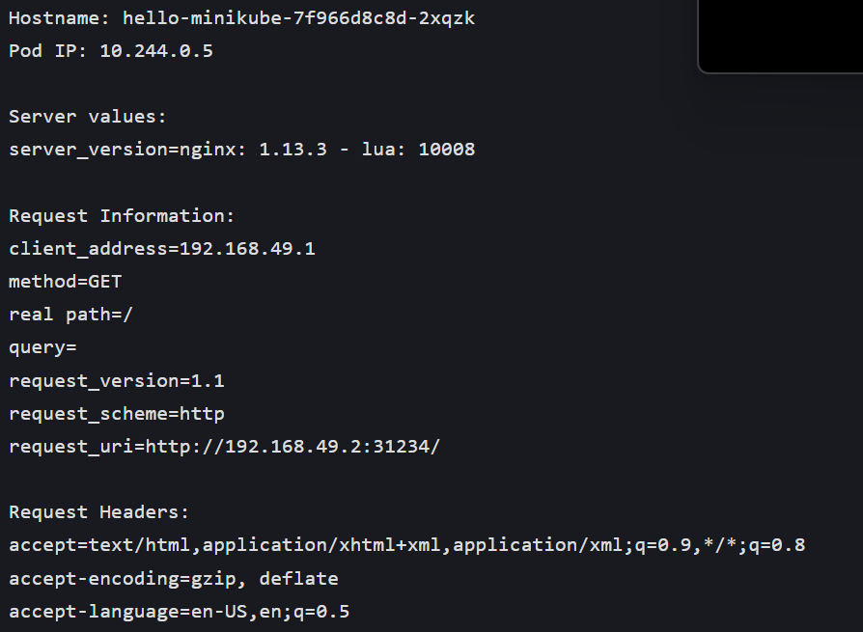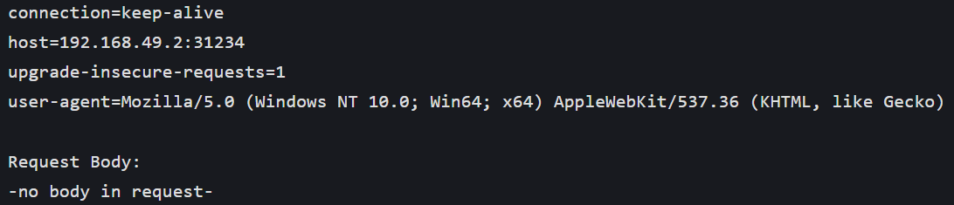
Step 5: Scale the App
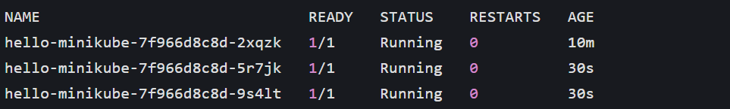
Simulated Load Balancing (Browser Refresh Output)
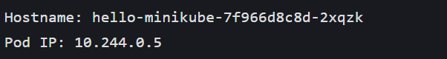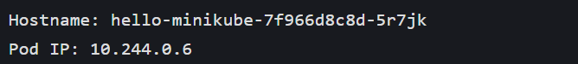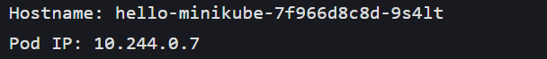

Step 6: Update the App (Rolling Update)
